Traditional Dream Catcher Series Workshop for Xyolhemeylh
Presented by FVACFSS Tradition Mentor – Colin Point
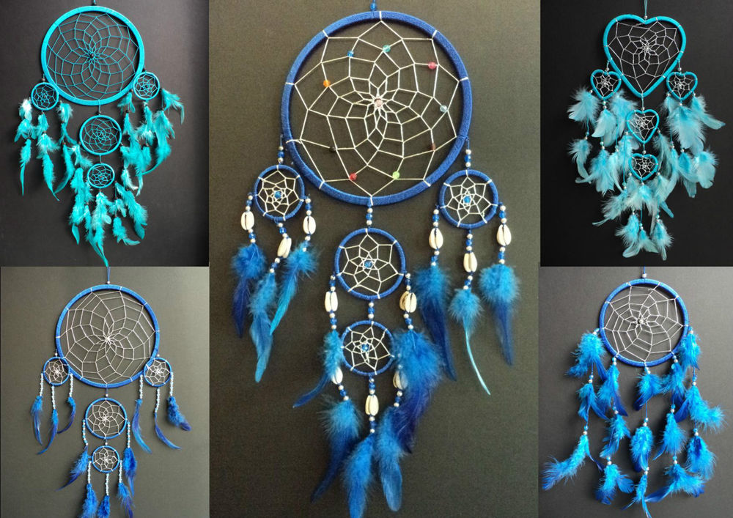
The Fraser Valley Aboriginal Children and Family Services Society, is pleased to announce a Dream catcher making workshop where you will have the opportunity to learn how to make a dream catcher.
Workshop #1
Thursday September 20th 2018
5:00-6:00pm.
34110 Lougheed Hwy Mission, B.C. V2V 4J4
Please notes seats are limited-10 participants per session, Ages (8-16)*
To register a child return completed registration form to Colin Point.
Phone: (604) 556-1730 or colin.point@xyolhemeylh.bc.ca
Child/Youth Registration:
Age
Gender
Date of birth: y/m/d
Name:
Address of current residence

Aboriginal Community:
Telephone Number:

Emergency contact name and telephone number:

Other important information (behavioural needs):
Medical concerns: (Allergies or medications)

Caregiver Information
Caregiver First and Last Name
FIRST REGISTERING CAREGIVER FIRST & LAST
Cell phone:

Home Telephone:

Address is different than child’s:

Can the caregiver provide transportation?

